Westpac JavaScript Coding Exercise

Introduction
Described below is a short coding exercise we use to demonstrate a candidate’s knowledge of HTML5/CSS3/JS programming and their ability to produce clean, well tested code. We expect candidates to spend no more than 2-3 hours on the exercise, so are not expecting production ready code. However we would like candidates to point out any assumptions they have made and limitations of their implementation.

Exercise details
Candidates are required to provide a website that lets the user play a game of Snap.
Here’s a wireframe of the interface we’re expecting for this. However, feel free to produce something different if it meets all the requirements listed below.
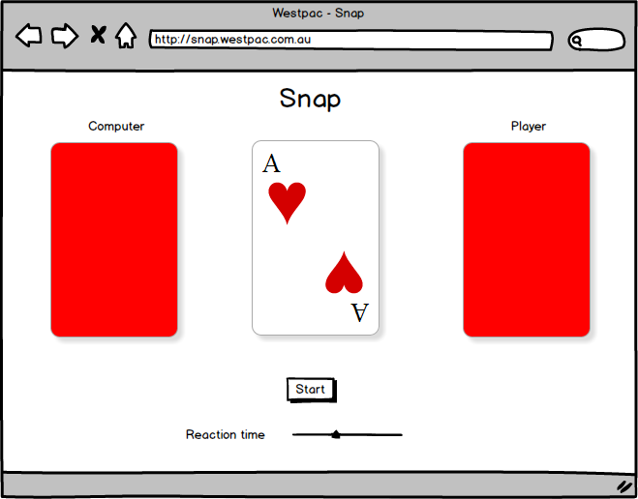

Game rules
- A standard deck of 52 player cards is shuffled at the start of each game
- Each player is dealt 26 cards from the deck.
- The first player to play is chosen at random each game
- Each player turns over the top card from their face-down pile and places it on the pile in centre middle.
- The player does this by clicking on their pile. The computer will do it automatically.
- When a card matches the previous card on the pile (e.g. two Aces in a row), the first player to ‘call snap’ wins the pile. The player does this by clicking the centre pile. The computer will automatically do this after a period of time (configurable by the reaction time slider at the bottom). The player who wins takes all the cards in the middle and places them at the bottom of their deck.
- Play continues until one player runs out of cards at which point the other player is the winner.
The implementation should provide the following:
- Some indicator to show who’s turn it is
- An indication of how many cards in each deck (can be as simple as changing the shadow of the deck)
- A button to clear the current game and start a new game
- An indication of who called snap first
- A slider to configure the reaction time of the computer to ‘calling snap’
Implementation considerations
- We’ve included a basic shell of the app including the card suit images. Feel free to modify any of these files as you see fit.
- We’re more interested in the JavaScript code than in the look and feel of the application. It’s fine for it to not look polished.
- Feel free to use any open source JavaScript framework(s) you think are appropriate
- You only need to support the latest version of Chrome. As such you can use any of the latest html elements, JavaScript language features or CSS3 tags.

Deliver your implementation as a zipped up project. We will run an HTTP server from the top level directory of the project (for instance via python -m SimpleHTTPServer ) and expect to be able to load index.html to see your site.

